**Unsupervised Learning**

* We have discussed how to train our machines with past data on the basis of which they can learn, gain intelligence, and apply that intelligence on a new set of data.
* There are, however, situations when we do not have any prior knowledge of the data set we are working with, but we still want to discover interesting relationships among the attributes of the data or group the data in logical segments for easy analysis.
* The task of the machine is then to identify this knowledge without any prior training and that is the space of unsupervised learning.
* We will discuss how Clustering algorithms help in grouping data sets into logical segments.
* Association analysis which enables to identify a pattern or relationship of attributes within the data set.
* An interesting application of the association analysis is the Market Basket Analysis, which is used widely by retailers and advertisers across the globe.

**What is Unsupervised Learning?**

* Unsupervised learning is a machine learning concept where the unlabelled and unclassified information is analysed to discover hidden knowledge.
* The algorithms work on the data without any prior training, but they are constructed in such a way that they can identify patterns, groupings, sorting order, and numerous other interesting knowledge from the set of data.

1. Clustering

2.Association Analysis

* **Clustering** is a broad class of methods used for discovering unknown subgroups in data, which is the most important concept in unsupervised learning.
* **Association Analysis** which identifies a low-dimensional representation of the observations that can explain the variance and identify the association rule for the explanation.

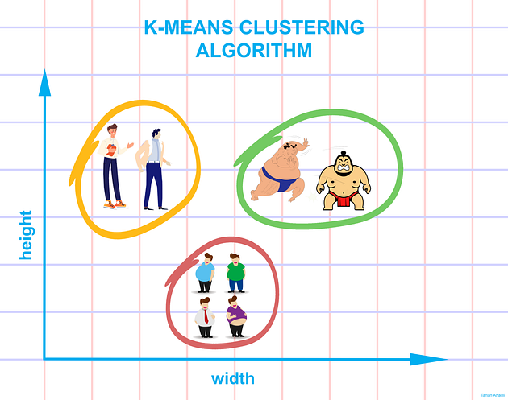

**Clustering**

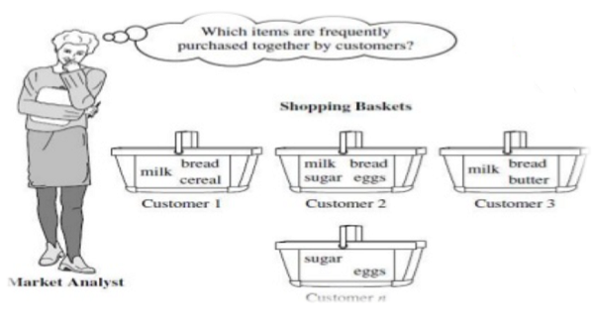

**Association Analysis**

**Applications of Clustering:**

* Segmentation of target consumer populations by an advertisement consulting agency on the basis of few dimensions such as demography, financial data, purchasing habits, etc. so that the advertisers can reach their target consumers efficiently
* Anomaly or fraud detection in the banking sector by identifying the pattern of loan defaulters.
* Image processing and image segmentation such as face recognition, expression identification, etc.
* Grouping of important characteristics in genes to identify important influencers in new areas of genetics
* Utilization by data scientists to reduce the dimensionalities in sample data to simplify modelling
* Document clustering and identifying potential labelling options



Unsupervised Learning

**Different types of clustering techniques**

**The major clustering techniques are:**

1. **Partitioning methods:**  
   These methods divide the dataset into a set number of clusters by optimizing a criterion, typically based on distance. They are efficient for large datasets but may struggle with non-globular cluster shapes.
   * **i. K-Means:**  
     Assigns data to clusters by minimizing the variance within each cluster; uses centroids to represent clusters.
   * **ii. K-Medoids:**  
     Similar to K-Means but uses actual data points (medoids) as centers, making it more robust to noise and outliers.
2. **Hierarchical methods:**  
   These build a hierarchy of clusters either from the bottom up or the top down, often represented as a tree (dendrogram). They do not require the number of clusters to be specified in advance.
   * **i. Agglomerative (Bottom Up Approach):**  
     Starts with each data point as a single cluster and merges the closest pairs step-by-step.
   * **ii. Divisive (Top Down Approach):**  
     Begins with one large cluster and recursively splits it into smaller clusters.
3. **Density-based methods:**  
   These methods form clusters based on the density of data points in the feature space, effectively identifying arbitrarily shaped clusters and handling noise.
   * **i. Density Based Spatial Clustering of Applications with Noise (DBSCAN):**  
     Groups together closely packed points and marks points in low-density regions as outliers.

**1.1 K-MEANS CLUSTERING –(Centroid Based Approach)**

* The principle of the *k*-means algorithm is to assign each of the ‘*n*’ data points to one of the *K* clusters where ‘*K*’ is a user defined parameter as the number of clusters desired.
* The objective is to maximize the homogeneity within the clusters and also to maximize the differences between the clusters.
* The homogeneity and differences are measured in terms of the distance between the objects or points in the data set.

**Simple Algorithm of *K*-means**

**Step 1:** Select *K* points in the data space and mark them as initial centroids

**loop**

**Step 2:** Assign each point in the data space to the nearest centroid to form K

clusters

**Step 3:** Measure the distance of each point in the cluster from the centroid

**Step 4:** Calculate the Sum of Squared Error (SSE) to measure the quality of

the clusters *(described later in this chapter)*

**Step 5:** Identify the new centroid of each cluster on the basis of distance

between points

**Step 6:** Repeat Steps 2 to 5 to refine until centroids do not change

**end loop**

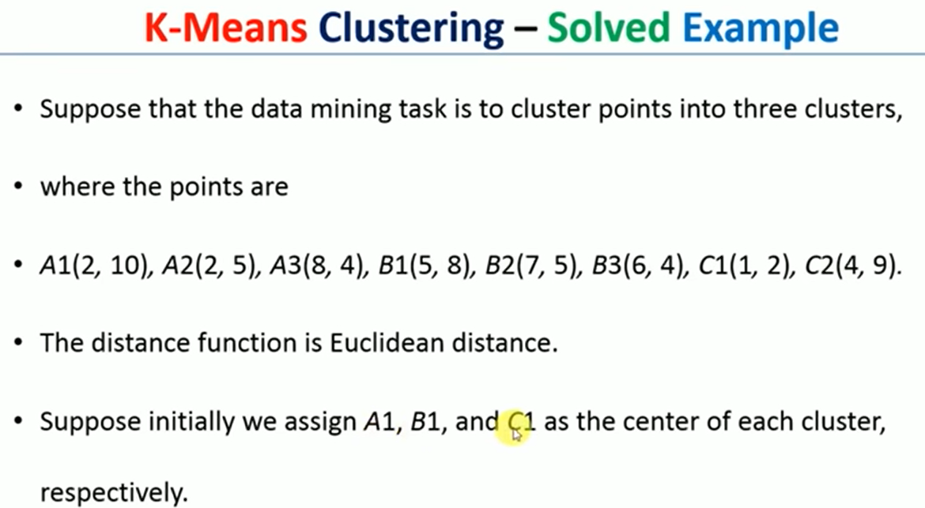

**LEVEL: 1**

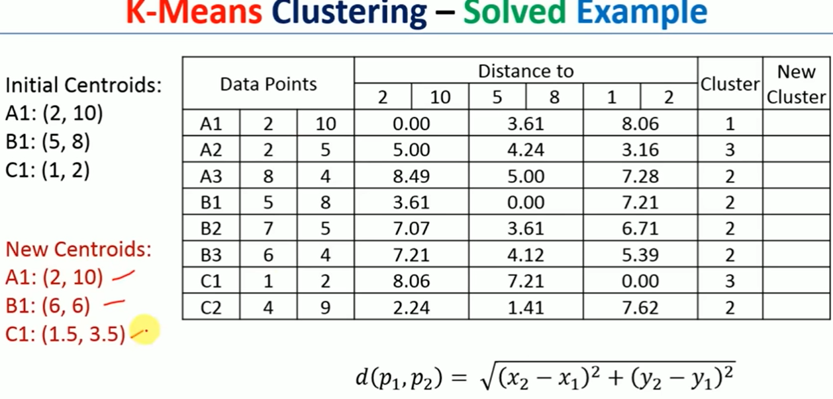

**LEVEL 2:**

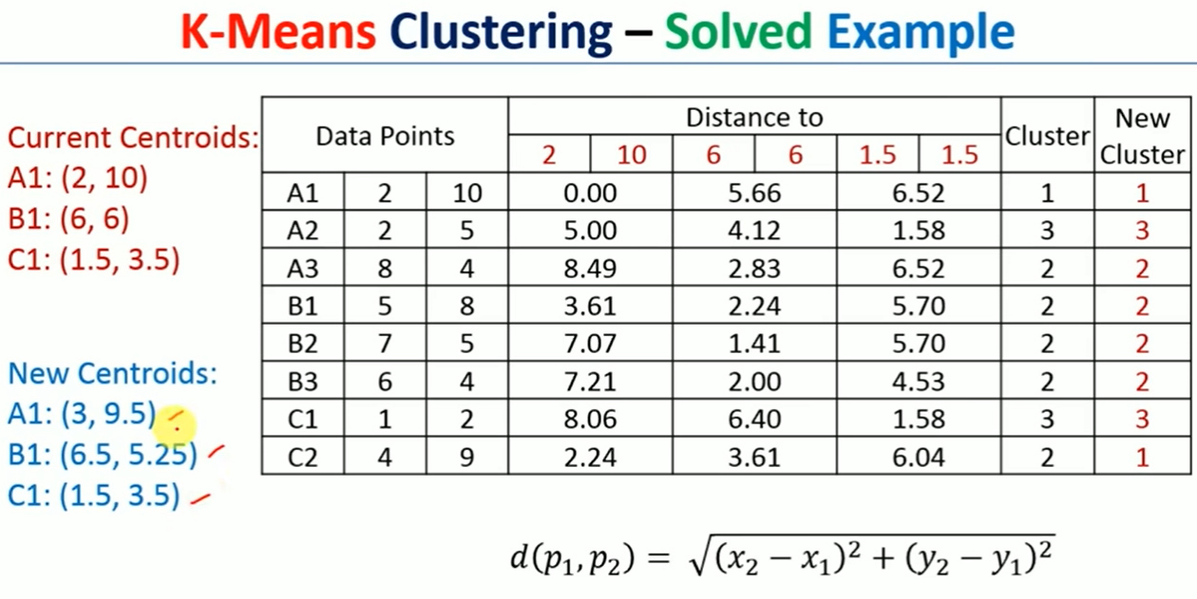

**LEVEL 3:**

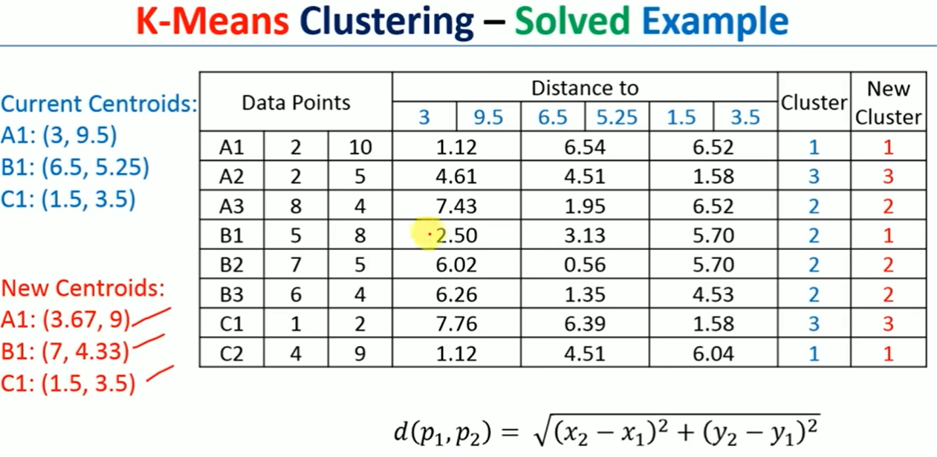

**LEVEL 4:**

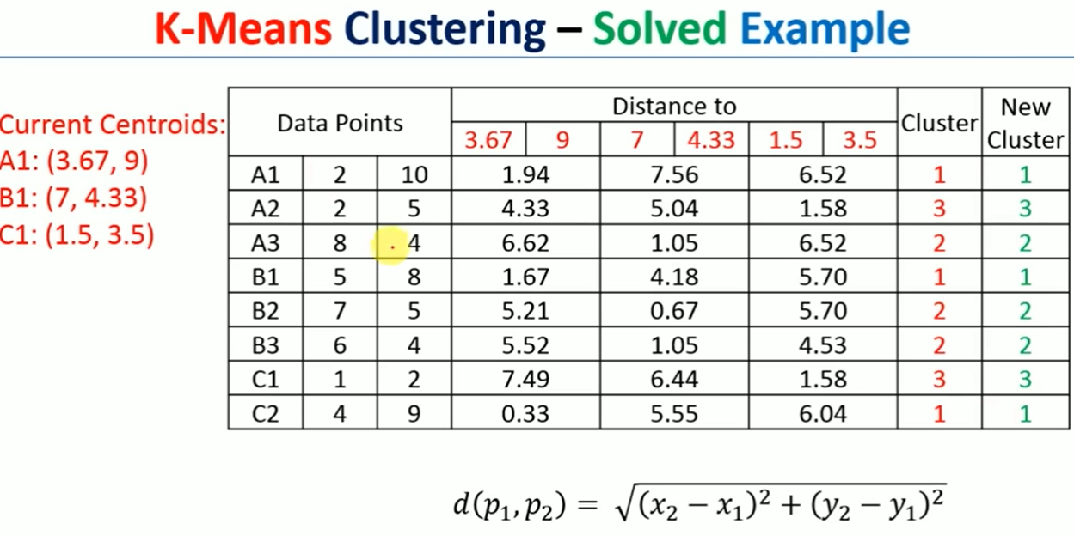

**Therefore The final Clusters are**

**Cluster 1: {A1,B1,C2}**

**Cluster 2: {A3,B2,B3}**

**Cluster 3: { A2,C1}**

How to find the optimal K value?

**Elbow method**

* This method tries to measure the homogeneity or heterogeneity within the cluster and for various values of ‘*K*’and helps in arriving at the optimal ‘*K*’. From Figure 9.5, we can see the homogeneity will increase or heterogeneity will decrease with increasing ‘*K*’ as the number of data points inside each cluster reduces with this increase.
* But these iterations take significant computation effort, and after a certain point, the increase in homogeneity benefit is no longer in accordance with the investment required to achieve it, as is

evident from the figure.

* This point is known as the elbow point, and the ‘*K*’ value at this point produces the optimal

clustering performance.



**1.2 K-Medoids Clustering :**

Partitioning Around Medoids (PAM) algorithm.

Algorithm 2: PAM

**Step 1**: Randomly choose *k* points in the data set as the initial representative

points

loop

**Step 2**: Assign each of the remaining points to the cluster which has the

nearest representative point

**Step 3**: Randomly select a non-representative point *o* in each cluster

**Step 4**: Swap the representative point *o* with *o* and compute the new SSE

after swapping

**Step 5**: If SSEnew < SSEold, then swap *o* with *o* to form the new set of *k*

representative objects;

**Step 6**: Refine the *k* clusters on the basis of the nearest representative point.

Logic continues until there is no change

end loop

K-Medoids Clustering Example (Step-by-Step)

# Step 1: Problem Statement

We are given 6 points in 2D space:  
A(1,1), B(2,1), C(2,2), D(8,8), E(9,8), F(9,9)  
We aim to cluster them using the K-Medoids algorithm with k = 2.  
Initial medoids are: B(2,1) and E(9,8)

# Step 2: Assign Each Point to the Nearest Medoid

Using Euclidean distance, assign each point to the closest medoid:

|  |  |  |  |
| --- | --- | --- | --- |
| Point | Distance to B(2,1) | Distance to E(9,8) | Assigned to |
| A(1,1) | 1.00 | 10.63 | Cluster 1 |
| B(2,1) | 0 | 9.90 | Cluster 1 |
| C(2,2) | 1.00 | 9.43 | Cluster 1 |
| D(8,8) | 9.43 | 1.00 | Cluster 2 |
| E(9,8) | 9.90 | 0 | Cluster 2 |
| F(9,9) | 10.82 | 1.00 | Cluster 2 |

# Step 3: Compute Total Cost

Cluster 1 (B): A to B = 1.00, B to B = 0, C to B = 1.00 => Total = 2.00  
Cluster 2 (E): D to E = 1.00, E to E = 0, F to E = 1.00 => Total = 2.00  
Total Cost = 4.00

# Step 4: Try Swapping Medoids

Try swapping B with A or C, and E with D or F:  
- Swap B → A: Cost = 2.41 + 2.00 = 4.41 (worse)  
- Swap E → D: Cost = 2.00 + 2.41 = 4.41 (worse)  
No swaps improved the cost.

# Step 5: Final Clusters

Medoids remain the same:  
- Cluster 1 medoid: B(2,1)  
- Cluster 2 medoid: E(9,8)  
  
Final Clusters:  
- Cluster 1: A(1,1), B(2,1), C(2,2)  
- Cluster 2: D(8,8), E(9,8), F(9,9)

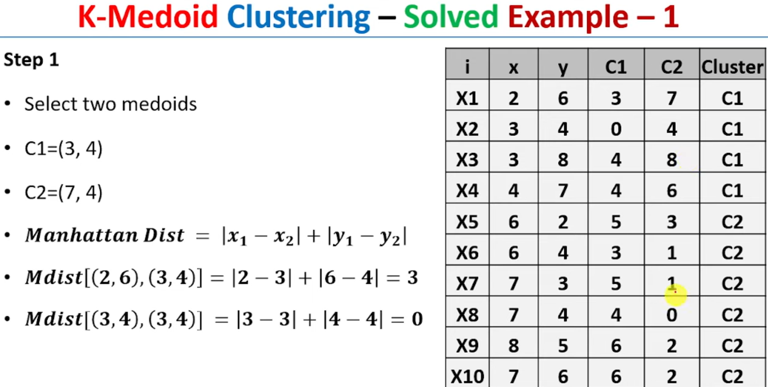

**STEP 2:**

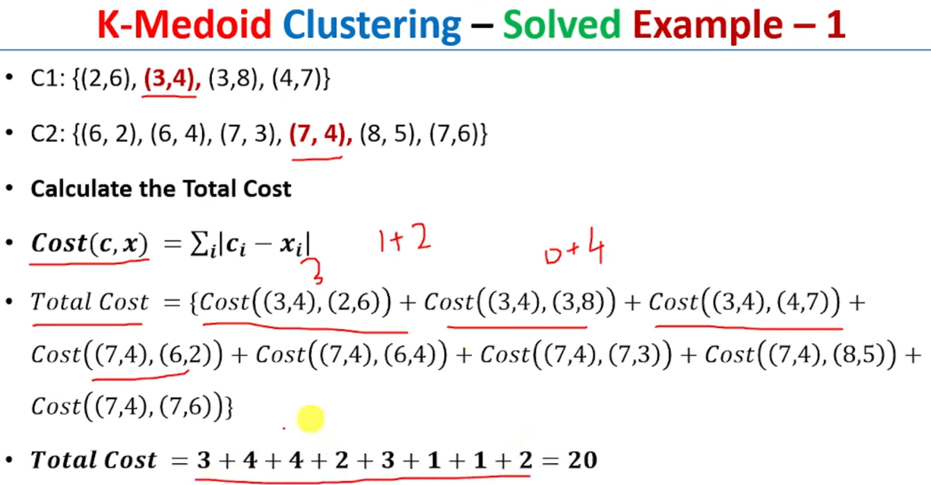

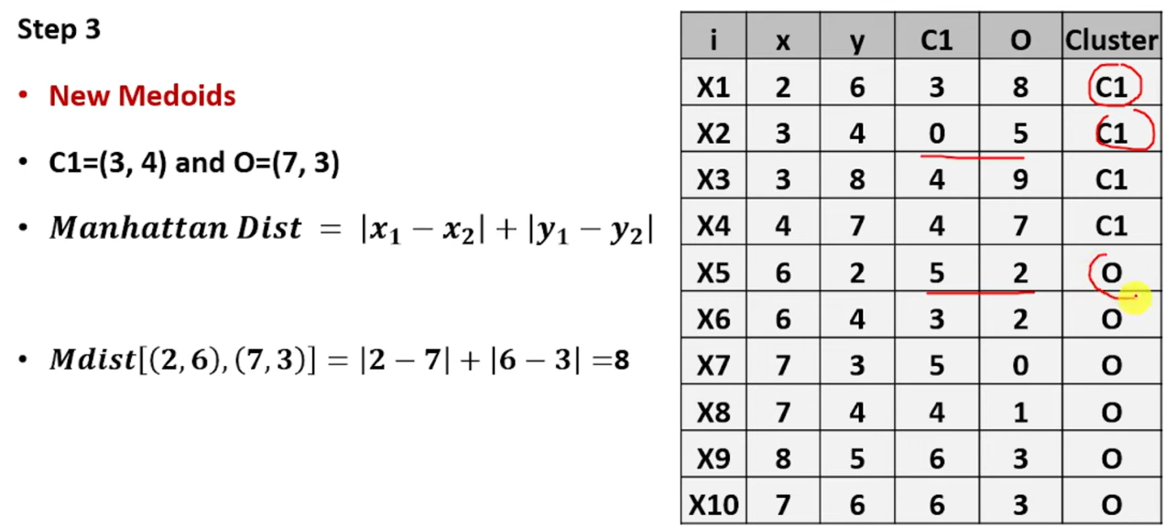

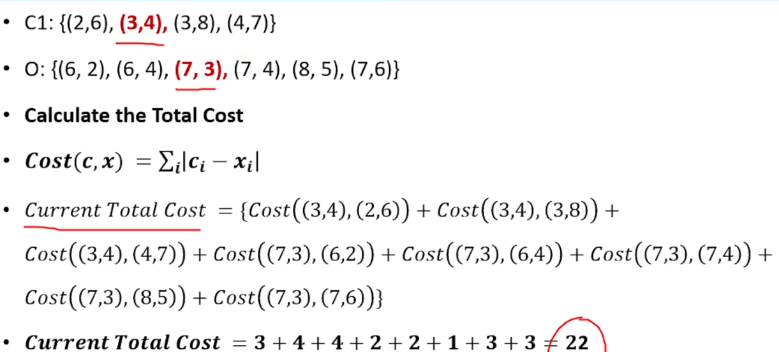

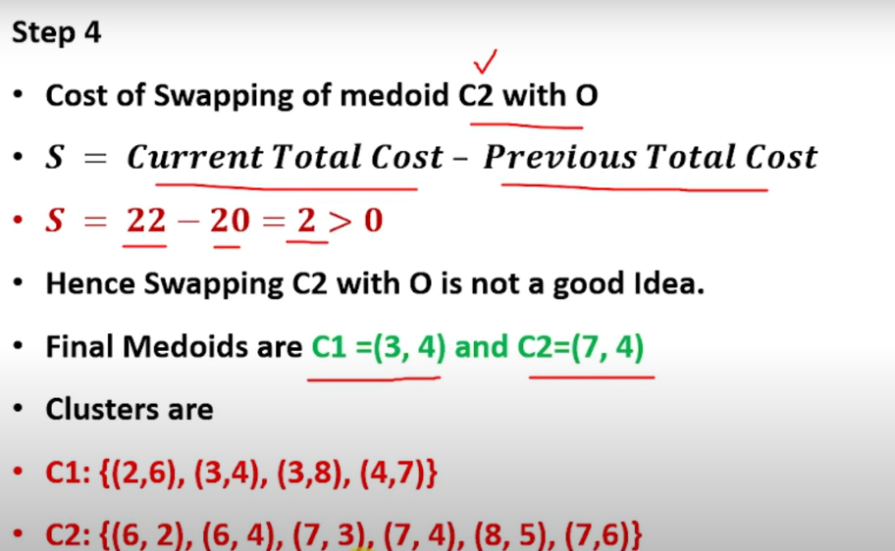

**2.Hierarchical Clustering**

**2.1 Agglomerative Clustering**

**What is Agglomerative Clustering?**

Agglomerative Clustering is a type of hierarchical clustering that follows a bottom-up approach.

* It starts by treating each data point as its own cluster.
* Then, it iteratively merges the two closest clusters until all points are merged into a single cluster (or until a stopping condition is met).

**How it Works – Step by Step:**

1. Initialization: Each data point is treated as an individual cluster.
2. Distance Calculation: Calculate the pairwise distances between all clusters.
3. Merging: Merge the two closest clusters (based on a selected linkage method).
4. Update Distance Matrix: Recalculate distances between the new cluster and the remaining clusters.
5. Repeat: Continue merging until the desired number of clusters is achieved or all points are merged into one cluster.

**Linkage Criteria (Ways to Measure Distance Between Clusters)**

* **Single Linkage**: Minimum distance between any point in cluster A and any point in cluster B.
* **Complete Linkage**: Maximum distance between any point in cluster A and any point in cluster B.
* **Average Linkage**: Average of all pairwise distances between points in the two clusters.
* **Ward’s Method**: Minimizes the total within-cluster variance.

**Dendrogram**

A dendrogram is a tree-like diagram that shows the merging process in hierarchical clustering.

* The height of the lines represents the distance at which clusters are merged.
* You can cut the dendrogram at a certain height to determine the number of clusters.

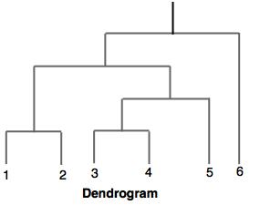

**Advantages**

* No need to pre-specify number of clusters (you can decide later by cutting the dendrogram).
* Works well with hierarchical data.

**Disadvantages**

* Computationally expensive for large datasets.
* Once a merge is made, it **cannot be undone** (greedy approach).
* Sensitive to noise and outliers.

**Step-by-Step agglomerative clustering process using Single Linkage** for the given dataset:

Here is the initial **Euclidean distance matrix** (rounded to 2 decimal places) for the 6 data points:

**Step 0: Initial Distance Matrix**

|  |  |  |  |  |  |  |
| --- | --- | --- | --- | --- | --- | --- |
|  | **P1** | **P2** | **P3** | **P4** | **P5** | **P6** |
| **P1** | 0 | 0.23 | 0.22 | 0.37 | 0.34 | 0.24 |
| **P2** | 0.23 | 0 | 0.14 | 0.19 | 0.14 | 0.24 |
| **P3** | 0.22 | 0.14 | 0 | 0.16 | 0.28 | 0.1 |
| **P4** | 0.37 | 0.19 | 0.16 | 0 | 0.28 | 0.22 |
| **P5** | 0.34 | 0.14 | 0.28 | 0.28 | 0 | 0.39 |
| **P6** | 0.24 | 0.24 | 0.1 | 0.22 | 0.39 | 0 |

**Step 1: Merge P3 and P6 (min distance = 0.10)**

|  |  |  |  |  |  |
| --- | --- | --- | --- | --- | --- |
|  | **P1** | **P2** | **P4** | **P5** | **P3_P6** |
| P1 | 0 | 0.23 | 0.37 | 0.34 | 0.22 |
| P2 | 0.23 | 0 | 0.19 | 0.14 | 0.14 |
| P4 | 0.37 | 0.19 | 0 | 0.28 | 0.16 |
| P5 | 0.34 | 0.14 | 0.28 | 0 | 0.28 |
| **P3_P6** | 0.22 | 0.14 | 0.16 | 0.28 | 0 |

**Step 2: Merge P2 and P5 (min distance = 0.14)**

|  |  |  |  |  |
| --- | --- | --- | --- | --- |
|  | **P1** | **P4** | **P3_P6** | **P2_P5** |
| P1 | 0 | 0.37 | 0.22 | 0.23 |
| P4 | 0.37 | 0 | 0.16 | 0.19 |
| P3_P6 | 0.22 | 0.16 | 0 | 0.14 |
| **P2_P5** | 0.23 | 0.19 | 0.14 | 0 |

**Step 3: Merge P3_P6 and P2_P5 (min distance = 0.14)**

|  |  |  |  |
| --- | --- | --- | --- |
|  | **P1** | **P4** | **P3_P6_P2_P5** |
| P1 | 0 | 0.37 | 0.22 |
| P4 | 0.37 | 0 | 0.16 |
| **P3_P6_P2_P5** | 0.22 | 0.16 | 0 |

**Step 4: Merge P4 and P3_P6_P2_P5 (min distance = 0.16)**

|  |  |  |
| --- | --- | --- |
|  | **P1** | **P4_P3_P6_P2_P5** |
| P1 | 0 | 0.22 |
| **P4_P3_P6_P2_P5** | 0.22 | 0 |

**Step 5: Merge P1 and P4_P3_P6_P2_P5 (min distance = 0.22)**

All points are now in a single cluster: **P1_P4_P3_P6_P2_P5**

**Step 6: Draw Dendrogram**

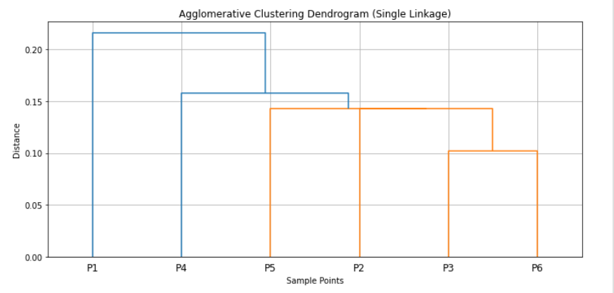

**Unsupervised Learning -Association Analysis**

**What is Association Analysis?**

**Association Analysis** is a rule-based machine learning method used to discover **interesting relationships** (associations) between variables in **large datasets**.

* It's mostly used in **market basket analysis** to find patterns like:  
  *"Customers who buy bread and butter also tend to buy jam."*

**Where is it used?**

* Market Basket Analysis (Retail)
* Recommender Systems
* Web usage mining
* Bioinformatics (e.g., gene associations)

**Key Terms in Association Rule Mining**

Let's say we are analyzing customer transactions in a store:

* **Itemset**: A collection of one or more items.  
  Example: {milk, bread}

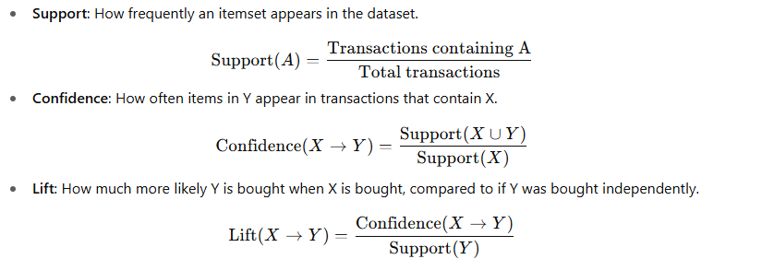

* + Lift > 1 → positive association
  + Lift = 1 → independent
  + Lift < 1 → negative association

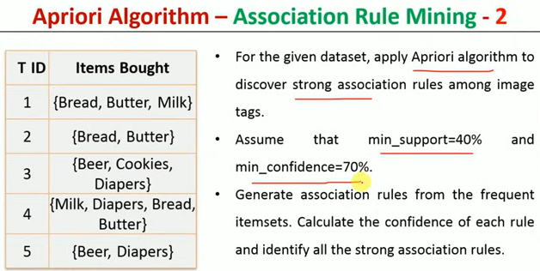

**Step 1: Transaction Data**

| **TID** | **Items Bought** |
| --- | --- |
| 1 | Bread, Butter, Milk |
| 2 | Bread, Butter |
| 3 | Beer, Cookies, Diapers |
| 4 | Milk, Diapers, Bread, Butter |
| 5 | Beer, Diapers |

**Step 2: Frequent 1-Itemsets (support ≥ 2)**

| **Item** | **Support Count** |
| --- | --- |
| Bread | 3 (T1, T2, T4) |
| Butter | 3 (T1, T2, T4) |
| Milk | 2 (T1, T4) |
| Diapers | 3 (T3, T4, T5) |
| Beer | 2 (T3, T5) |
| Cookies | 1 (T3) |

Frequent 1-itemsets:   
**{Bread}, {Butter}, {Milk}, {Diapers}, {Beer}**

**Step 3: Frequent 2-Itemsets (support ≥ 2)**

| **2-itemset** | **Support Count** | **TIDs** |
| --- | --- | --- |
| Bread, Butter | 3 | T1, T2, T4 |
| Bread, Milk | 2 | T1, T4 |
| Butter, Milk | 2 | T1, T4 |
| Diapers, Beer | 2 | T3, T5 |

Other 2-itemsets like Bread & Diapers or Butter & Diapers have support < 2.

Frequent 2-itemsets:   
**{Bread, Butter}, {Bread, Milk}, {Butter, Milk}, {Diapers, Beer}**

**Step 4: Generate Candidate 3-Itemsets**

We now combine 2-itemsets that share two items:

Candidate: **{Bread, Butter, Milk}**  
Appears in:

* TID 1
* TID 4
* So, **Support = 2** → **Frequent**

So finally, **frequent 3-itemsets** =  
**{Bread, Butter, Milk}**

**Step 5: Final List of Frequent Itemsets**

* 1-itemsets: Bread, Butter, Milk, Diapers, Beer
* 2-itemsets: {Bread, Butter}, {Bread, Milk}, {Butter, Milk}, {Diapers, Beer}
* 3-itemsets: {Bread, Butter, Milk}

**Step 6: Generate Association Rules**

We now generate all **non-trivial rules** from itemsets of size ≥ 2.

**From 2-itemsets:**

1. Bread → Butter = 3/3 = **100%**
2. Butter → Bread = 3/3 = **100%**
3. Bread → Milk = 2/3 = **66.7%**
4. Milk → Bread = 2/2 = **100%**
5. Butter → Milk = 2/3 = **66.7%**
6. Milk → Butter = 2/2 = **100%**
7. Diapers → Beer = 2/3 = **66.7%**
8. Beer → Diapers = 2/2 = **100%**

**From 3-itemset: {Bread, Butter, Milk}**

Subset rules:

* Bread + Butter → Milk = 2/3 = **66.7%**
* Bread + Milk → Butter = 2/2 = **100%**
* Butter + Milk → Bread = 2/2 = **100%**
* Bread → Butter, Milk = 2/3 = **66.7%**
* Butter → Bread, Milk = 2/3 = **66.7%**
* Milk → Bread, Butter = 2/2 = **100%**

**Final Strong Rules (Confidence ≥ 70%)**

| **Rule** | **Support Count** | **Confidence** | **Strong?** |
| --- | --- | --- | --- |
| Bread → Butter | 3 | 100% | yes |
| Butter → Bread | 3 | 100% | yes |
| Milk → Bread | 2 | 100% | Yes |
| Milk → Butter | 2 | 100% | Yes |
| Beer → Diapers | 2 | 100% | Yes |
| Bread + Milk → Butter | 2 | 100% | Yes |
| Butter + Milk → Bread | 2 | 100% | Yes |
| Milk → Bread + Butter | 2 | 100% | yes |

**Final Count = 8 Strong Association Rules**

DBSCAN Algorithm -Density based Clustering Technique

**What is DBSCAN?**

* DBSCAN, which stands for Density-Based Spatial Clustering of Applications with Noise, is a powerful clustering algorithm that groups points that are closely packed together in data space.
* Unlike some other clustering algorithms, DBSCAN doesn't require you to specify the number of clusters beforehand, making it particularly useful for exploratory data analysis.
* The algorithm works by defining clusters as dense regions separated by regions of lower density.
* This approach allows DBSCAN to discover clusters of arbitrary shape and identify outliers as noise.

DBSCAN revolves around three key concepts:

1. **Core Points**: These are points that have at least a minimum number of other points (MinPts) within a specified distance (ε or epsilon).
2. **Border Points**: These are points that are within the ε distance of a core point but don't have MinPts neighbors themselves.
3. **Noise Points**: These are points that are neither core points nor border points. They're not close enough to any cluster to be included.

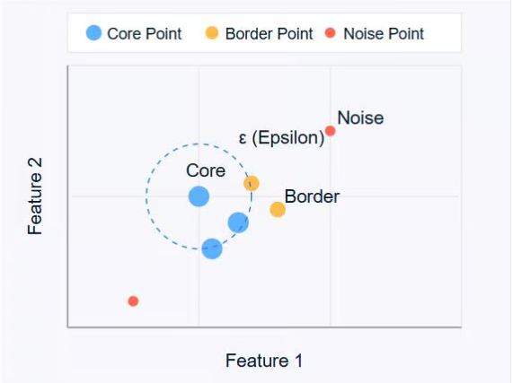

The diagram above illustrates these concepts. Core points (blue) form the heart of clusters, border points (orange) are on the edge of clusters, and noise points (red) are isolated.

DBSCAN uses two main parameters:

* **ε (epsilon)**: The maximum distance between two points for them to be considered as neighbors.
* **MinPts**: The minimum number of points required to form a dense region.

By adjusting these parameters, you can control how the algorithm defines clusters, allowing it to adapt to different types of datasets and clustering requirements.

**How Does DBSCAN Work?**

DBSCAN operates by examining the neighborhood of each point in the dataset. The algorithm follows a step-by-step process to identify clusters based on the density of data points. Let's break down how DBSCAN works:

1. **Parameter Selection**
   * Choose ε (epsilon): The maximum distance between two points for them to be considered as neighbors.
   * Choose MinPts: The minimum number of points required to form a dense region.
2. **Select a Starting Point**
   * The algorithm starts with an arbitrary unvisited point in the dataset.
3. **Examine the Neighborhood**
   * It retrieves all points within the ε distance of the starting point.
   * If the number of neighboring points is less than MinPts, the point is labeled as noise (for now).
   * If there are at least MinPts points within ε distance, the point is marked as a core point, and a new cluster is formed.
4. **Expand the Cluster**
   * All the neighbors of the core point are added to the cluster.
   * For each of these neighbors:
     + If it's a core point, its neighbors are added to the cluster recursively.
     + If it's not a core point, it's marked as a border point, and the expansion stops.
5. **Repeat the Process**
   * The algorithm moves to the next unvisited point in the dataset.
   * Steps 3-4 are repeated until all points have been visited.
6. **Finalize Clusters**
   * After all points have been processed, the alg orithm identifies all clusters.
   * Points initially labeled as noise might now be border points if they're within ε distance of a core point.
7. **Handling Noise**
   * Any points not belonging to any cluster remain classified as noise.

This process allows DBSCAN to form clusters of arbitrary shapes and identify outliers effectively. The algorithm's ability to find clusters without specifying the number of clusters beforehand is one of its key strengths.

It's important to note that the choice of ε and MinPts can significantly affect the clustering results.

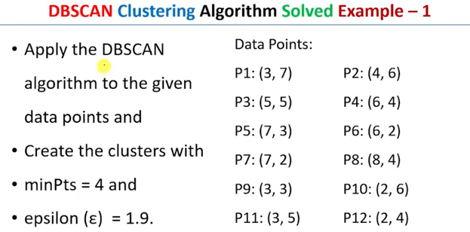

Step 2: Calculate the distance matrix

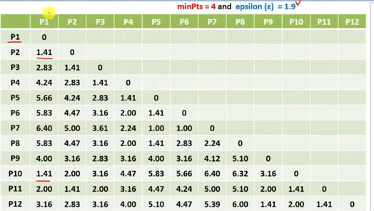

Step 3: Find the clusters within the Eplison range

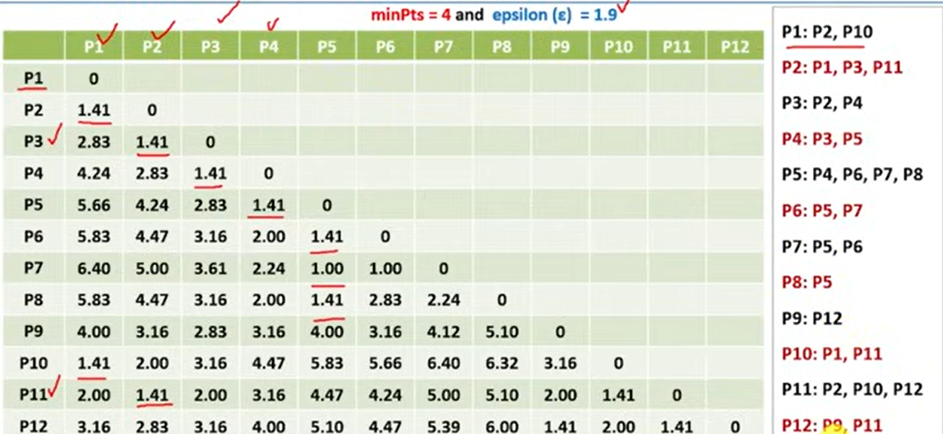

Step 4:Find Core, Noise points based on Minimum points =4 .Surround by less than 4 then it is Noise points.

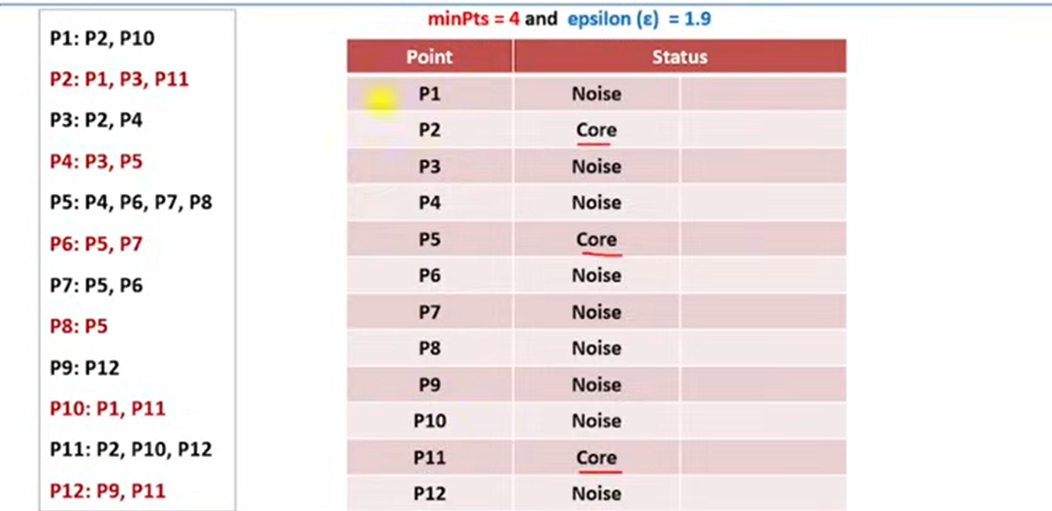

Step 5: Find border point ,if a point is part of any core datapoint the it is border point

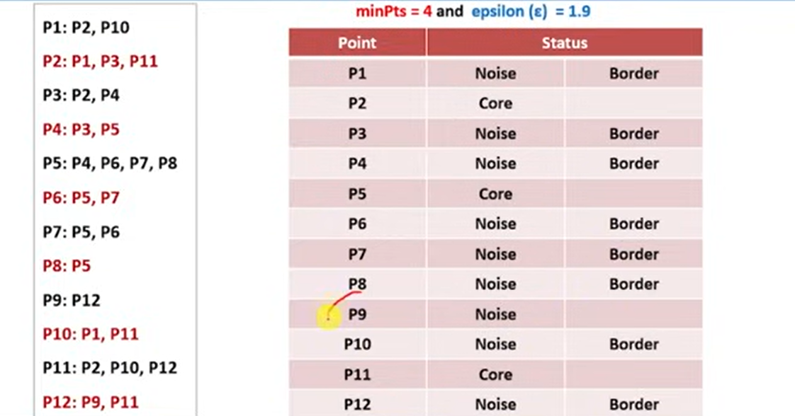

Step 6: Visualise the clusters

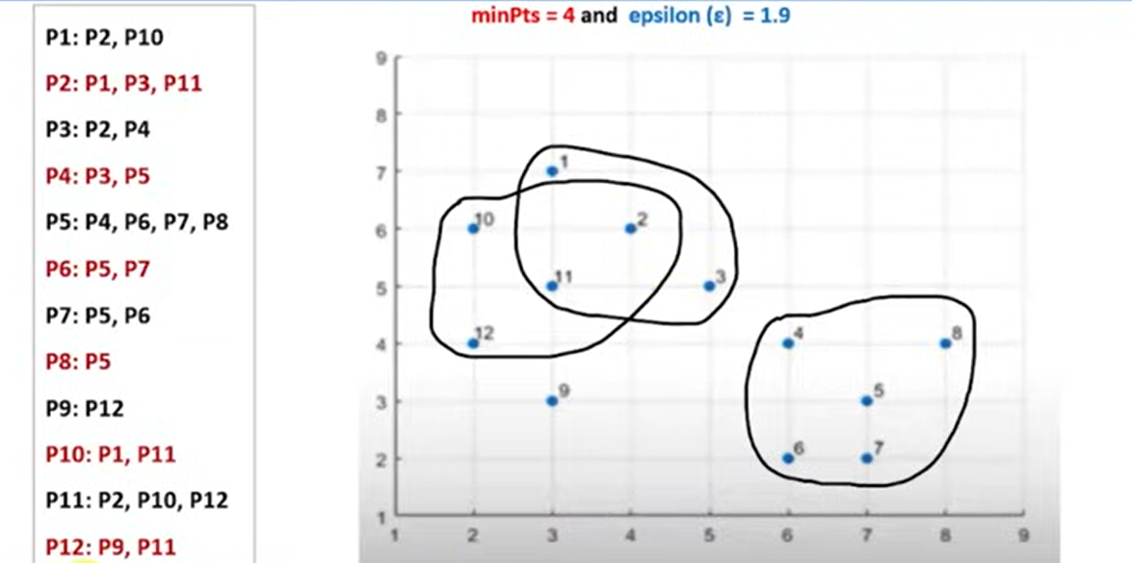

* P9 is not a part of any cluster so it is a noise point